**S-Locker**

**The Design Manual**

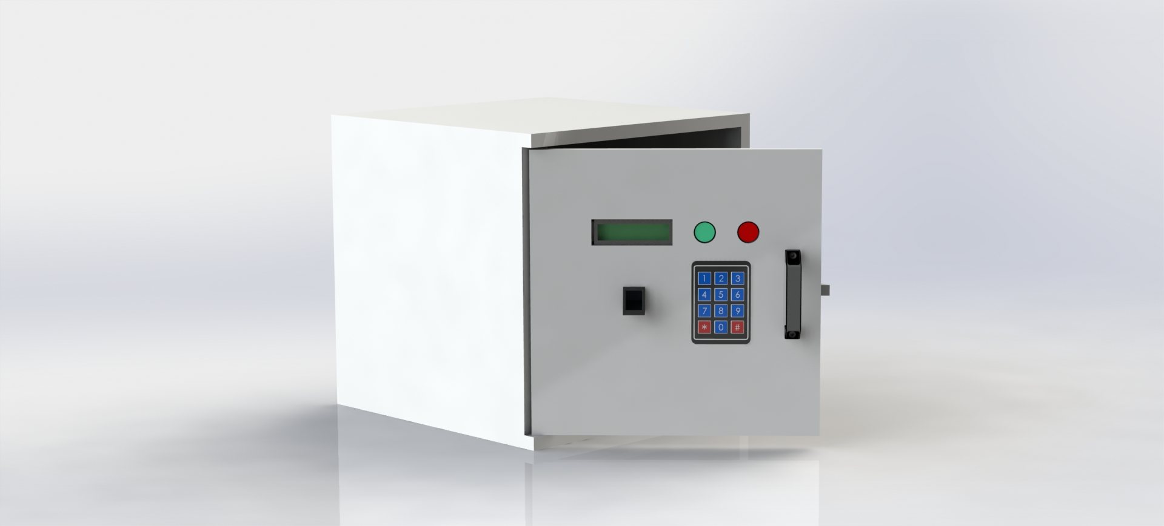

**Power-Up System of the locker**

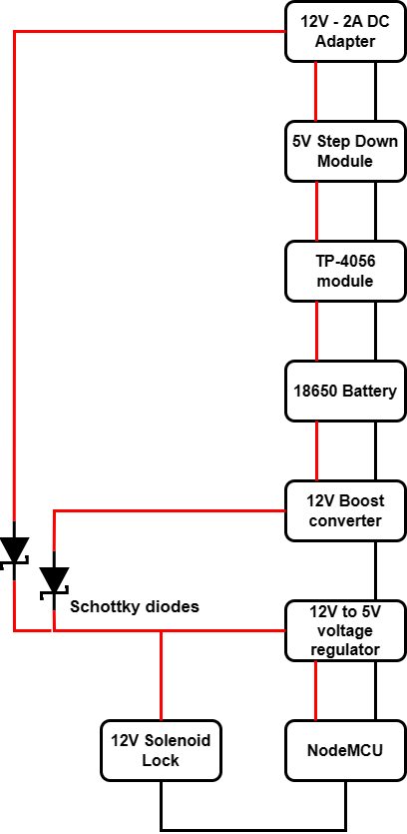

The device will mainly be powered by the main current, and it can function on battery power when the main power goes off.

The main current will be supplied to the circuit via a 12V, 2A power adapter.

Since the NodeMCU only needs 5V to operate, a 12V to 5V circuit was implemented. Main power Directly comes to the 12V to 5V voltage regulator circuit and the solenoid lock.

Also, the main power will step down to 5V and be connected to the TP-4056 charging module, which has protection. The charging module will connect to a 18650 battery. Since the module has charge protection, it will avoid overcharging and over-discharging the battery.

Battery output will be connected to the boost converter, and the output will be connected to the 12V to 5V voltage regulator circuit and the solenoid lock. (Backup power option).

Two Schottky diodes were used to control the current direction, and Schottky diodes were used because they only caused a 0.2V voltage drop.